Hadamard matrix

Intro

Def

Property

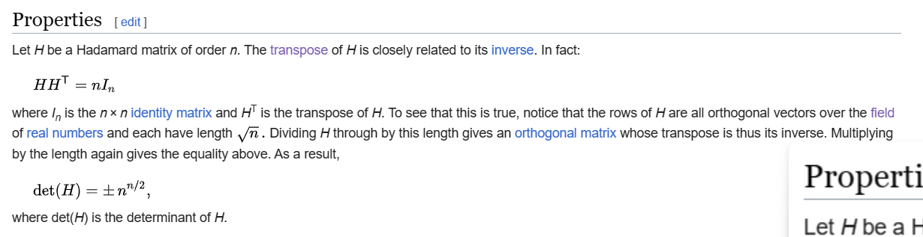

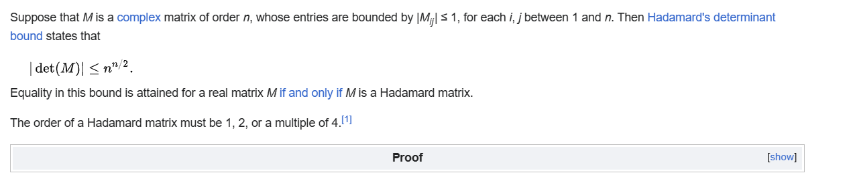

Proof

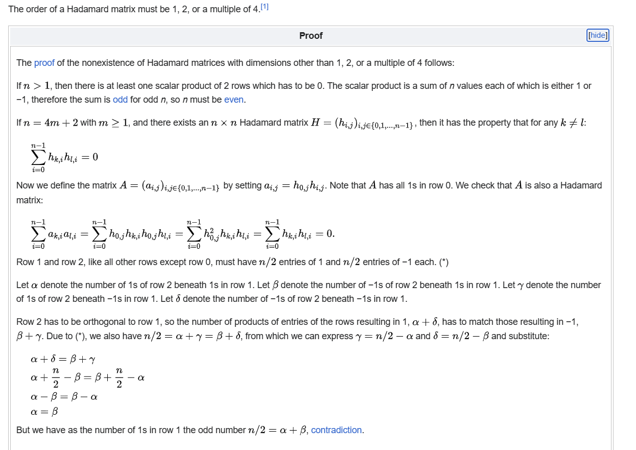

Ref

[Hadamard matrix - Wikipedia](https://en.wikipedia.org/wiki/Hadamard_matrix)